EXP 18 5G NR Frame Structure Analysis with different Subcarrier Spacing

AIM
To simulate 5G network slicing by dynamically allocating bandwidth to eMBB, URLLC, and mMTC slices based on priority and evaluating their throughput, latency, and bandwidth distribution.

THEORY
1. Network Slicing
- A 5G technique that divides a physical network into multiple logical slices, each optimized for a different service.
- Each slice has unique QoS parameters such as data rate, latency, bandwidth, and reliability.
2. Three Major 5G Slices
- eMBB (Enhanced Mobile Broadband): High throughput, large bandwidth.
- URLLC (Ultra-Reliable Low-Latency Communications): High priority, low latency, mission-critical services.
- mMTC (Massive Machine-Type Communications): Handles many devices, low data-rate IoT traffic.
3. Priority-Based Allocation
- Bandwidth is dynamically distributed using weighted priorities:
$$BW_{alloc}=BW_{total}×\frac{P_{i}}{∑P}$$
4. Throughput
$$T=BW×\text{Spectral Efficiency}$$
5. Latency
- URLLC must maintain sub-millisecond latency.
- eMBB and mMTC allow higher latency.

PROCEDURE (Exactly 6 Lines)
- Define total bandwidth and the bandwidth/throughput requirements for eMBB, URLLC, and mMTC.
- Assign priority values to each slice based on QoS needs.
- Compute dynamic bandwidth allocation using normalized priority weights.
- Calculate throughput using allocated bandwidth and spectral efficiency.
- Simulate random latency values representing realistic 5G slice performance.
- Plot throughput, latency, and bandwidth allocation for all slices.

PSEUDO CODE
START
SET total bandwidth and slice requirements
DEFINE priority weights for eMBB, URLLC, mMTC
CALCULATE BW_alloc = total_BW * (priority / sum(priority))
COMPUTE throughput = BW_alloc * spectral_efficiency
SIMULATE latency values for each slice
DISPLAY results and PLOT throughput, latency, and BW allocation
END

CODE:
clear; clc; close all;

%% Total available bandwidth (MHz)
BW_total = 100;

%% Slice Requirements
% eMBB: High throughput
% URLLC: Ultra low latency, high priority
% mMTC: Large number of devices, small packets

req_eMBB = 50; % Required Mbps
req_URLLC = 20; % Required Mbps
req_mMTC = 10; % Required Mbps

priority = [2 3 1]; % 1=low, 3=high priority (URLLC > eMBB > mMTC)

%% Dynamic Bandwidth Allocation
BW_alloc = zeros(1,3);
req = [req_eMBB req_URLLC req_mMTC];

% Weighted allocation based on priority
priority_weights = priority ./ sum(priority);
BW_alloc = BW_total * priority_weights;

%% Compute Throughput (T = BW * spectral efficiency)
SE_eMBB = 6; % bits/s/Hz
SE_URLLC = 4;
SE_mMTC = 1;

th_eMBB = BW_alloc(1)*1e6 * SE_eMBB / 1e6;
th_URLLC = BW_alloc(2)*1e6 * SE_URLLC / 1e6;
th_mMTC = BW_alloc(3)*1e6 * SE_mMTC / 1e6;

%% Latency Simulation (URLLC minimum)
lat_eMBB = 20 + rand*10; % ms
lat_URLLC = 1 + rand*0.5; % ms
lat_mMTC = 50 + rand*20; % ms

%% Print Results
fprintf("\n===== Network Slicing Simulation Results =====\n");
fprintf("Allocated Bandwidth (MHz): eMBB=%.2f, URLLC=%.2f, mMTC=%.2f\n", BW_alloc(1), BW_alloc(2), BW_alloc(3));
fprintf("Throughput (Mbps): eMBB=%.2f, URLLC=%.2f, mMTC=%.2f\n", th_eMBB, th_URLLC, th_mMTC);
fprintf("Latency (ms): eMBB=%.2f, URLLC=%.2f, mMTC=%.2f\n", lat_eMBB, lat_URLLC, lat_mMTC);

%% Plot Throughput Comparison
figure;
bar([th_eMBB, th_URLLC, th_mMTC]);
set(gca, 'XTickLabel', {'eMBB','URLLC','mMTC'});
ylabel('Throughput (Mbps)');
title('Slice-wise Throughput Performance');

%% Plot Latency Comparison
figure;
bar([lat_eMBB, lat_URLLC, lat_mMTC]);
set(gca, 'XTickLabel', {'eMBB','URLLC','mMTC'});
ylabel('Latency (ms)');
title('Slice-wise Latency Performance');

%% Plot Bandwidth Allocation
figure;
pie(BW_alloc, {'eMBB','URLLC','mMTC'});
title('Dynamic Bandwidth Allocation for 3 Network Slices');
OUTPUT
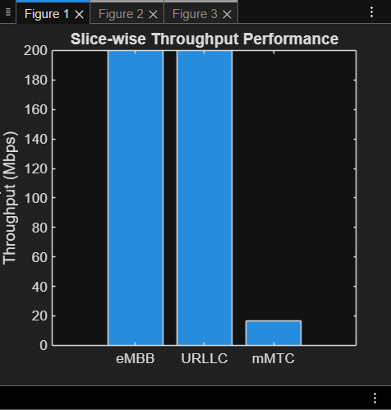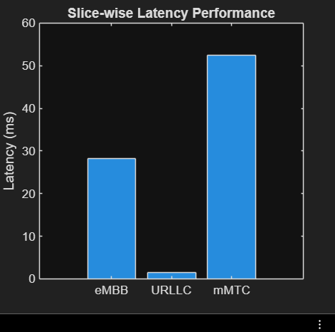

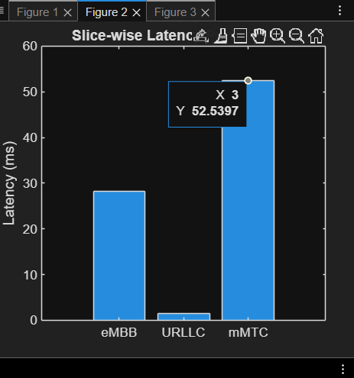

Conclusion :
• Priority-based dynamic slicing allocates more bandwidth to URLLC, ensuring low latency and reliability.
• eMBB achieves the highest throughput as expected due to higher spectral efficiency.
• mMTC receives minimal bandwidth but still supports a large number of small IoT packets.
• The simulation demonstrates how 5G slicing efficiently balances speed, reliability, and scalability among different services.

